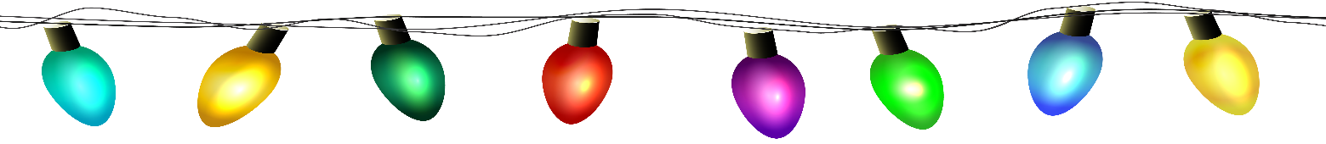

Dear Valued Clients of CVH,
We are writing to wish you and your fur kids a very happy Holiday season! May the Holidays you and your family celebrate be joyful and safe!
We want to share our Holiday hours of operation with you so you can plan ahead for any veterinary needs or concerns your pets may have. Also letting you know the days we will be closed, so our doctors and staff can take a little break and enjoy the Holidays too!
REGULAR BUSINESS HOURS:
December 1, 2025 – December 23, 2025, Monday-Friday, 8:00am-5:00pm, closed Saturdays & Sundays
HOLIDAY BUSINESS HOURS:
December 24, 2025 8:00am-12:00pm
December 25, 2025 – December 28, 2025 CLOSED
December 29 & December 30, 2025 8:00am-5:00pm
December 31, 2025 8:00am – 2:00pm
January 1, 2026 – January 4, 2026 CLOSED
We will return with regular business hours, 8:00AM-5:00PM on Monday, January 5, 2025
If your pet(s) require veterinary care during this extended Holiday closure we suggest you contact the Veterinary Emergency Clinics of Central Florida. They offer multiple locations with varying hours; the Casselberry location is open 24hr/7days. They can be reached at 407-644-4449.
We understand that it can be frustrating when we are not available to see your pet(s). After 30+ years of taking care of thousands of dogs and cats, Dr. Zern and the crew need (and deserves) a little extra time off to enjoy the Holidays. Thank you for understanding this needed break for him and our dedicated staff.
Again, we wish you all a joyful Holiday season and all the best in 2026!
Pawsitively yours,
Dr. Zern, Laura, and the entire CVH staff

